“Everest Flight” also known as “Mountain Flight “ The best way to see Mt. Everest and the Himalayas in Nepal

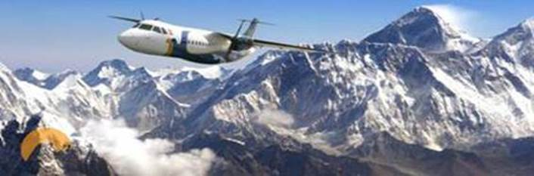

For the traveler who is unable to make a trekking trip to the mountains either because of lack of time or physical fitness, or due to sheer want of the adventure streak, there mountain flights to simulate the experience.

The one-hour flight takes you within camera range of some of the highest peaks in the world, and cruising this close to the awe in inspiring massifs of rock and ice, is an out-of-this earth experience. The aircraft takes off and heads eastward and almost immediately, the peaks come into view. The first peak that appears on your horizon is the majestic Gosaithan, standing 8,013m tall. To its right, appears Dorje Lhakpa (6996m), looking like a massive figure of 8, lying prone and covered in snow. To its right is Phurbi Chyachu, which looms over the Kathmandu valley.

Next on your vision is Choba Bhamare, rather small in this company at 5,933m, but singularly stubborn, as it remains unconquered to this day. Then comes MT. Gaurishanker (8,134m), standing out sharp and conspicuous- Hindus believe that Lord Shiva and his consort Parvati protect this mountain.

As the flight moves toward the eastern Himalaya, a succession of majestic mountains follows. Melungtse, with a plateau-like top stands at 7,023m, Chugimago is at 6,297m, and still remains to be scaled. At 6,956m, Mt.Numbur resembles a breast, and is believed to be the maternal source in the sky providing pure mild to the Sherpas of Solukhumbu. Then, Karyolung, a gleaming-white mountain at 6,511m, and Cho-Oyu, the sixth highest in the world at 8,021m. The last and the most exciting stretch of the journey takes you close to the 7,952-tall Gyachungkang, which is considered extremely tough climb. To its right is Puman at 7,161m and Nuptse at 7,855m. Finally, there is Mt. Everest itself (8,848m), called Sagarmatha by the Nepalis and Chomolungma by the Tibetans. It is an altogether different feeling as one comes face to face with the worlds tallest and most enigmatic of mountains.

COST FOR MOUNTAIN / Everest FLIGHT
Inr. 12500 per adult / child for the air ticket and Hotel Transfers –
subject to change as per the airlines policy ( inclusive of service charge ), applicable for Indian Nationals only.

Zip Line – In Pokhara
Pokhara is an adventure paradise, offering activities such as paragliding, trekking, mountain biking, canyoning, rafting, kayaking, jungle tours and much more. We take this opportunity to add another dimension to the awesomeness in adventure Nepal has to offer. We are proud to introduce to you the World’s Most Incredible Zipline, Zip-Flyer by HighGround Adventures.

The Zip-Flyer by HighGround Adventures is not just another zip line. At a 56% incline, 1.8km in length, 2000 ft vertical drop and speeds of over 140 km ph, makes this the most extreme ride in the world. A ride of this magnitude has never been built before and we assure that this ride will truly be a unique experience.

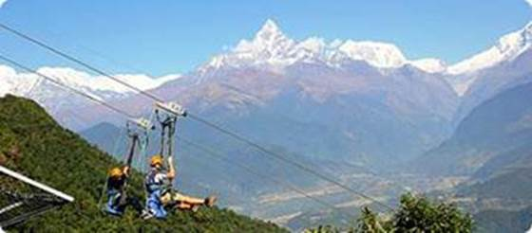

This system by Zip-flyer™ LLC, USA is designed with the most advanced technologies, creating a state-of-the-art zipline. Every part of this ride is creatively designed to provide unparalleled performance, precision engineered and manufactured to equal or surpass ANSI-B77 Tramway, ASTM, and TUV SUD codes.

We hereby officially propose to you to include us in your in-bound tourist itineraries and sell our amazing product through your network. Please find below herewith the financial details of our offer for your valuable consideration.

COST FOR ZIP LINE:
Inr 6800 per person (Inclusive of service charge , Photo & Video in a Download Link includes T-shirt)
The above cost includes:
Pick-up from High Ground Office ( HGA ) at Lakeside, Pokhara main City. Off city limits pick up is not done. Drive to High Ground Zip-Flyer Launch Pad in Sarangkot
Zip-Flyer ride drop-off to High Ground office at Lakeside, Pokhara. Transportation from Hotel to High Ground office and back is not included and will have to be managed by the clients on their own.

Para Gliding – In Pokhara

Paragliding is a relatively new adventure sport in Nepal, and little information is available in tourist guidebooks. Paragliding in this Himalayan country can be a truly wonderful and fulfilling experience unparalleled scenic grandeur

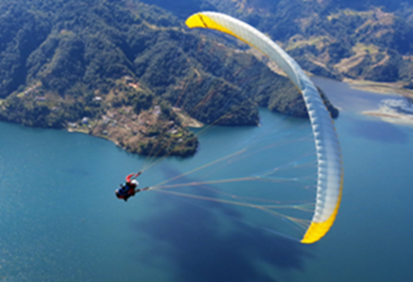

as you share airspace with Himalayan griffin vultures, eagles, kitesd, while floating over villages, monasteries, temples, lakes and jungles, with a fantastic view of the majestic Himalayas. The last couple of years have seen the activity flourishin Pokhara, and it is now an internationally recognized destination for free-flight enthusiasts.

COST FOR PARA GLIDING
20-25 minutes (depending on the warmness of the air ) – Inr. 8500 per person inclusive of Photos and Video.

Para gliding operates from Sarankot, Pokhara. The paragliding company will pick up the clients from their office and take them to the paragliding Take Off Spot.
Pick up will be from the City Center. For the drop point, they will drop the clients at the lakeside area. From here to the hotel, the clients will have to manage on their own.

Ultra Light Flight – In Pokhara

Ultralight aircraft was introduced in Nepal in 1996. The operator hvae been offering sightseeing tours in the Pokharas Valley. The choice of Pokhara
for “Ultra-light” aircraft is appropriate chiefly because of the proximity of the mountains, and the ice lakes. For those who wish they could fly like birds,
this flight is a must. Leave your woes behind on earth, soar to heights, bathe in the clouds, reach out for the mountains and kiss the azure sky. It might be
lonely at the top, but the spectacular view from high up there certainly makes up for everything. The company operates flights from the Pokhara airport.
The flights take place from 11 a.m. to 3p.m.
(Timings vary at times depending on the Weather)

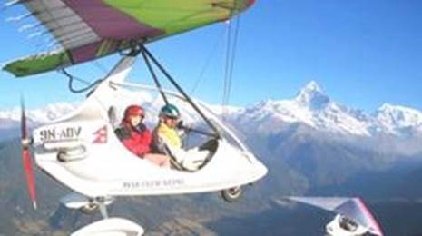

COST FOR ULTRALIGHT FLIGHT
- Fly for Fun: Duration 15 minutes. The aircraft flies over the Pokhara city, Phewa Lake, Sarangkot hill. At the speed of 50-90 km/hr. The maximum altitude attained is 5,000 feet. This flight is designed for the Fun- lover.
- Inr. 12000 per person with Photos and Video (including service charge ).

Hotel – Airport – Hotel transfers will cost extra: Inr. 2200 per A/c car for both way transfers
The service has two ultra-light aircraft of the model “Biman-1”. Designed and manufactured in Russia, by Biman Company Ltd, the delta wing aircraft fitted with “ROTAX582” engine and weighing 170 kg, has an operational speed of 50 km/hr to 130 km/hr. The use of aviation-grade aluminum alloys, Dracron, Parachute Recovery System (which will help the aircraft to land safely in case of emergency), world-class piston and satellite-assisted navigation GPS,
has enhanced safety while keeping the weight to a minimum. Ultralights can take off and land in a field or on a dirt road, and in areas where other planes fear to tread. The aircraft seats two persons at a time, it being a passenger and the pilot.

Bungee Jump in Pokhara
If you thought bungee jumping was restricted to some places in Europe, New Zealand and America, it’s time you got an update. The sport has finally found a natural home in the highest mountain range in the world. The ultimate thrill of a bungy jump can

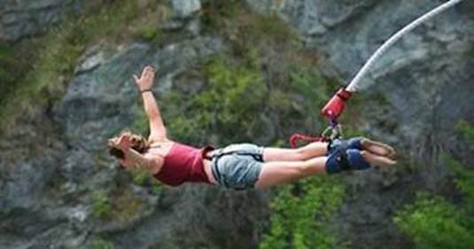

now be experienced in Nepal at perhaps the best site in the world.

COST FOR BUNGY JUMPING:
Inr.4800 per person ( including service charge, Photo & Video in a Download Link includes T-shirt )

This cost includes pick up from the HGA ( High Ground Office ) at the lake side Pokhara.
Drive to High Ground Bungee station. Do the jump. Drive back to HGA office.
Average time taken is 3-3.5 hours depending on the rush. Transportation from Hotel to HGA office and back is not included and will have to be managed by the clients on their own.

Rafting – On Trishuli River
The fact that you want to raft down Nepal’s chall-enging rivers means that you have long ago graduated from the nursery school of “Row, row, row your boat”. The many ‘raftable’ rivers in Nepal meander between canyons, villages, and virgin forests, wildlife, like needle through thread, weaving the country’s rich tapestry of ethno-culture and bio-diversity. Originating in the bowels of the Himalayas, these rivers flow across the length and breadth of Nepal and
neighboring India, before emptying mostly into the Bay of Bengal.
Season: October through mid-December and March through early May are the best times.
It is possible in winter too, but you have to watch out for hypothermia.
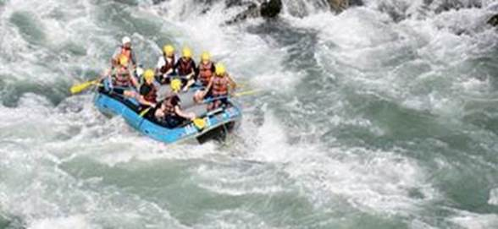
During monsoon (June through September), the white water sections are challenging.

COST FOR RAFTING:
Inr. 3000 per person rafting with other participants ( Rafting Cost only ).
One can do rafting while driving from Kathmandu to Pokhara or Chitwan, by which there will be no extra cost on the transportation. If the same is to be done Kathmandu to Kathmandu then the transportation cost will be additional.
Do ask for the same.

RAFTING IN POKHARA:

Pokhara is one of the best places in the world to experience diversified adventure activities. Rafting is also once of the exciting that people do not want to miss in Pokhara. Rafting in Pokhara is on the seti River. The starting pont of rafting is 30 minutes drive from Lakeside, Pokhara. The rafting will for a an hour.
The rafting activities takes. It is for a half day from pickup at your hotel at The Lakeside,
and drop you at your hotel at the Lakeside after finishing of the rafting.

COST FOR RAFTING:
Inr. 4000 per person. Rafting with other participants- including pick up drop from Lake side area only, with veg lunch & insurance,

Bungee Jumping at the Last Resort – Nepal / Tibet border
A day trip for the activity from Kathmandu is definitely possible. One will have to start pretty early so that one can get back to Kathmandu in time.
The distance though is only 110 kms one way, the mountain driving does take time. One should book the adventure activity in advance with us as at times the activities tend to get Full.
Bungee cost is Inr 6500 PP
Cost for transportation Kathmandu /Kodari ( The last Resort )/ Kathmandu by a non a/c car will be Inr. 12500.( pickup from Kathmandu drop to Kodari and next day pickup from kodari and drop to Kathmandu)

BALLONING
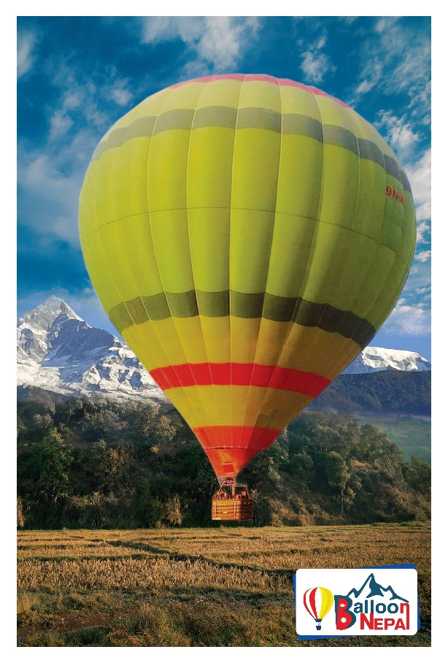

Balloon flight Information:

Flight time: Morning flight (between 5:30 am to 9:30 am Evening flight (between 3:15 pm to 6:00 pm)
Flight area inside the Paame Valley within
radius of 3 kms
Flight time : 30-40 mins of flight (depending upon the weather)
Flight capacity : 8 pax or 580 kgs
Cost: : Inr.12500 per person

Includes: Insurance of passengers on board during the flight as per Civil Aviation Authority of Nepal (CAAN) rules.

Skydiving

Skydiving is one of the adventurous sports that gives you an experience of a lifetime. With a platform like Pokhara, make sure to enjoy to the fullest and erase all the pressure from your normal life. A thrilling skydiving experience is offered in the heart of Pokhara.
Skydivers will jump from helicopters at a hight of 12000 feet/ 3652 meters west of Phewa Lake under the fuidance of a highly experienced and professional skydiving crew.

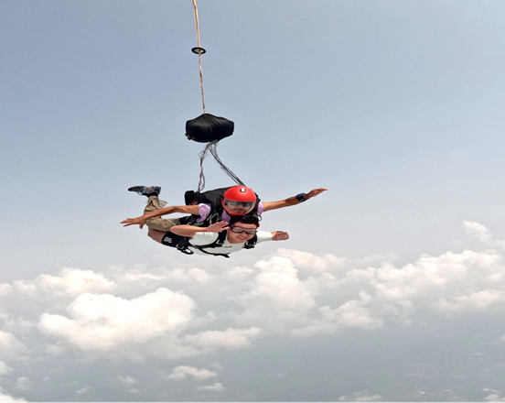

Skydiving cost:
Inr.68750 per person - booking prior 5 days minimum is to be done.
It is includes transportation, insurance, photo and videos, helicopter jump.

Above Rates ae subject to change as per Adventure Companies.
Do note that once an Adventure Activity is booked and paid for, the respective Company will not entertain any refunds for whatsoever reason.

The above adventure activities once booked and if cancelled due to what so ever reason, the same will be none refundable.

The above rates are Nett & Valid for Indian Nationals holding Indian Passport / Voter’s ID only.
The rates will not stand good for any other nationality. OCI and PIO is not valid in Nepal and cannot be used as an identification for Indian Nationals.

Terms and conditions for booking the Adventure Activities :
# Full Refund for all adventure activities will be done incase of any cancellations due to weather, technical reasons, cancelation by the Adventure Company. The cost for the transportation as per the activity will be non refundable
# No refund will be made once the activity has been booked and confirmed if cancelled. due to any reason - what so ever reason for cancellation ( Fear Factor ).

Sincerely hope you will find the above to your expectations and look forward to hear from you.

Warm Regards
Rishav


Nebuti Travels P. Ltd.
Building No. 453 / 40
3rd Floor, Kalika Marg, Kalikhasthan,(Land Mark - Adjoining Amrit Bhog Party Palace)
Telephone: +977 1 4422833, 4422834, 4522825, 4522824,4543492
Hand Phone Rishav Agarwal / Whats app no + 977 9801025057
Hand Phone Anil Agarwal : +977 9851025057
Nebuti Travels P. Ltd.
Building No. 453 / 40
3rd Floor, Kalika Marg, Kalikhasthan,(Land Mark - Adjoining Amrit Bhog Party Palace)
Kathmandu, Nepal
Telephone: +977 1 4522833, 4522834, 4522825, 4522824, 4543492
Hand Phone Rishav Agarwal / Whats app no + 977 9801025057
Hand Phone Anil Agarwal / Whats app no : +977 9851025057
Hand Phone Sangeeta / Whats app no : +977 9802376925
Hand Phone Roshni / Whats app no: +977 9802376926
Hand Phone Sushma / Whats app no : +977 9802376928

Email : info@nebuti.com;anil@nebuti.com
www.nebuti.com

